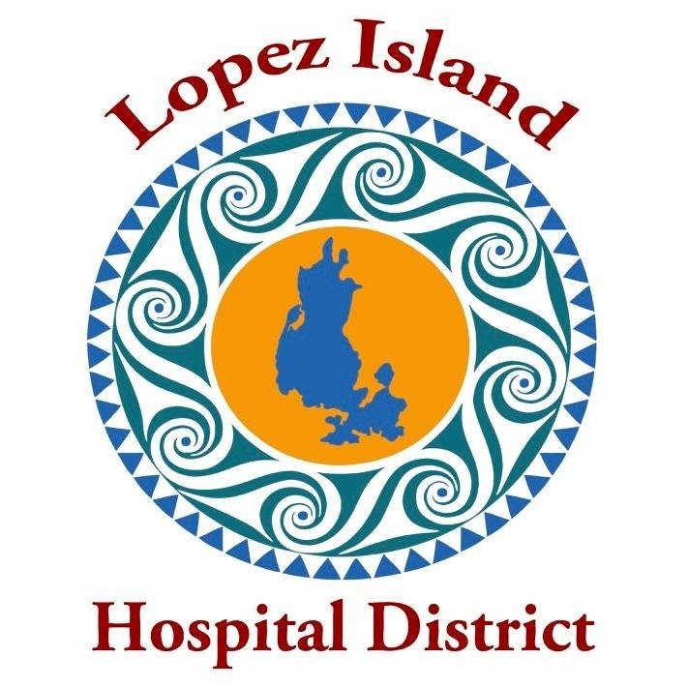
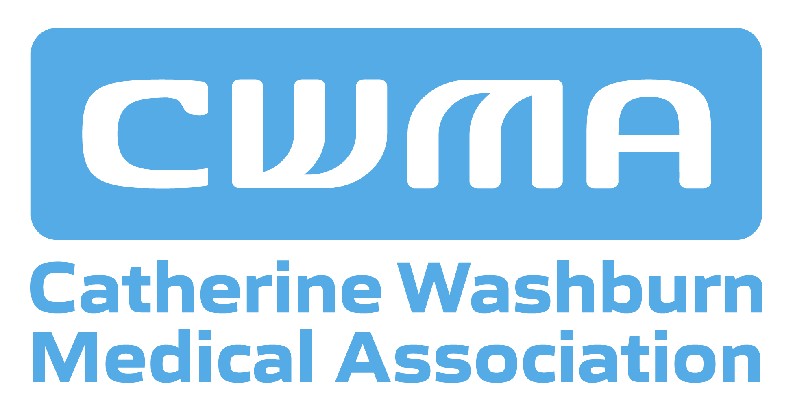

FAQs on Sea Mar Community Health Centers,
Proposed Operator of the Lopez Medical Clinic

Will Sea Mar accept my insurance?
Sea Mar accepts many major types of insurance, including Medicare, Medicaid, Ambetter, United HealthCare, WellPoint, Molina, and CHPW. For a full list of insurance accepted by Sea Mar, visit https://lopezislandhd.org/sea-mar-2026-health-dental-insurance-list/

Will I be able to call the Lopez Clinic directly, or will I be routed to a Sea Mar call center?
Patients will call the Lopez Clinic directly to schedule appointments and for other needs.

What about a closer partnership with Lopez Fire/EMS?
Sea Mar has agreed to grant 24/7 access to the clinic for use by Lopez Fire/EMS in order to stabilize patients.

Will Sea Mar provide a doctor for Lopez?
Sea Mar has agreed that the Lopez Clinic will have a minimum of 1.5 FTE medical providers, at least one of which will be a doctor. After a final contract is signed, Sea Mar will work to recruit a doctor for the Lopez Clinic.

I’m seeing a UW specialist in Seattle. Will I be able to continue to do that under Sea Mar?
Sea Mar has agreed to honor patient preferences in referrals to specialists and hospitals.

All my health records are in MyChart – how will I access them?
EPIC/MyChart is the records system used by Sea Mar health clinics, so we anticipate a smooth transition between UW and Sea Mar.

When would the clinic be open under Sea Mar?
Sea Mar has agreed to operate the clinic Monday – Friday, 8 am – 5 pm, at a minimum. The clinic will operate in the same building.

Will Sea Mar have a relationship with independent Lopez health care providers?
Sea Mar has met with Lopez Pharmacy, Lopez Physical Therapy, and Lopez-based Bayview Dental and toured their facilities to start building strong working relationships.

Why is Sea Mar interested in expanding to Lopez? Will we matter to Sea Mar when they have 90 other clinics around Washington State?
Serving the health care needs of a small, remote community is in keeping with Sea Mar’s mission of delivering high quality health care to underserved communities. Sea Mar is enthusiastic about the prospect of operating the Lopez Clinic, which would be aligned with their thriving Skagit County practice. Sea Mar has indicated that they are planning for the long-term and would like to attract more Lopezians to use the Lopez Clinic.

What will happen to the current Lopez Clinic staff? How will Sea Mar recruit medical providers to our remote island?
Sea Mar has agreed to offer a position to every current clinic staff member and match their current salary. Sea Mar has a proven record of recruiting medical providers in small communities and remote rural areas and offer programs to attract staff, such as paid training programs for medical assistant prospects.

What about after-hours care?
Sea Mar offers after-hours telephone triage and medical advice.

I’m not familiar with SeaMar. What do their patients think of the care they receive?
Patient experience surveys shared by Sea Mar from 2025 indicate high levels of patient satisfaction, especially interactions with medical providers.

What makes Sea Mar a good fit for Lopez?
Operating more than 90 community-based clinics, Sea Mar has a 48-year history of delivering quality primary health care to diverse communities in Washington State. Many Sea Mar clinics are located in small communities and rural areas, including eight Skagit clinics in Mount Vernon, Anacortes and Concrete. Sea Mar is a Federally Qualified Health Center, which will enable the Lopez Medical clinic to receive additional federal funding.

Founded by Latino community activists and health care advocates, Sea Mar was one of the first community health centers accredited by Joint Commission and has received the Gold Seal of Approval by demonstrating compliance with national standards for health care quality and safety. Reviews of their quality outcomes indicate high quality health care at a reasonable cost.

Visit https://lopezislandhd.org/clinic-transition-faq/ for answers to Frequently Asked Questions about the clinic transition. For background on the clinic transition, visit https://lopezislandhd.org/transition/

Find meeting announcements, agendas, and background documents at https://lopezislandhd.org/news/
For a full list of accepted Sea Mar Health and Dental insurance, visit https://lopezislandhd.org/sea-mar-2026-health-dental-insurance-list/

To learn more about Sea Mar’s mission, visit https://www.seamar.org/

