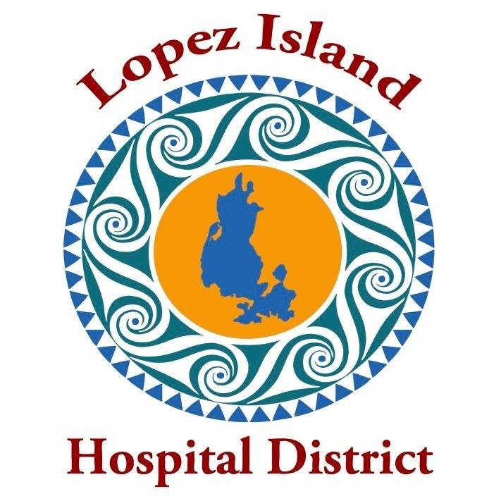
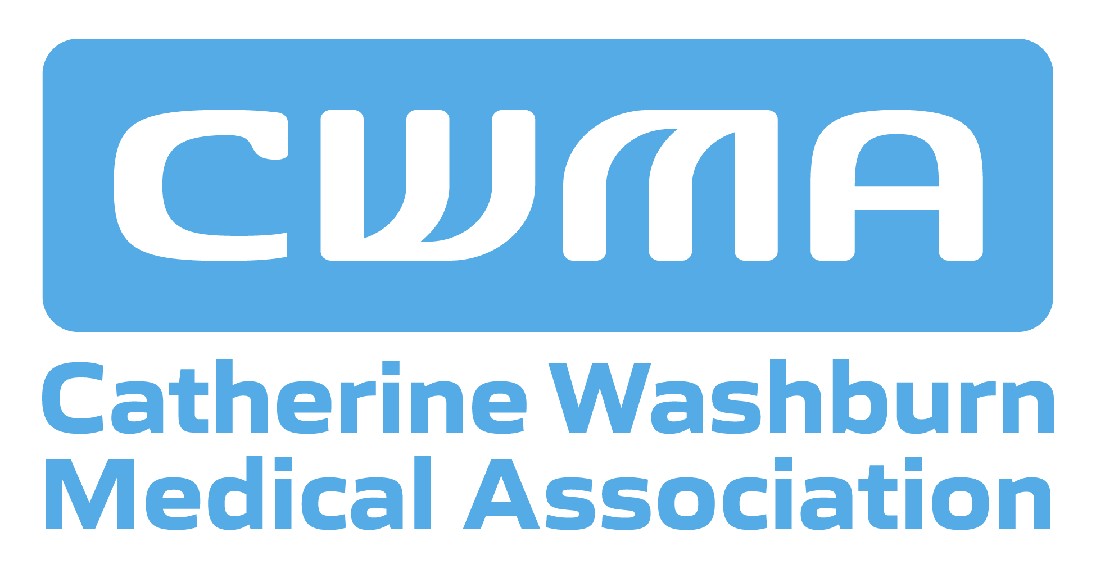

FOR IMMEDIATE RELEASE CONTACT:
March 14, 2026 Edee Scriven, 360-468-1845
superintendent@lopezislandhd.org

MARCH 17 LIHD SPECIAL MEETING TO REVIEW AND POTENTIALLY APPROVE SEA MAR CONTRACT TO OPERATE LOPEZ MEDICAL CLINIC

The Lopez Island Hospital District (LIHD) and Catherine Washburn Medical Association (CWMA) announced today that negotiations are complete with Sea Mar Community Health Centers (Sea Mar) to assume operation of the Lopez Island Medical Clinic when the clinic contract with UW ends.

LIHD has negotiated a clinic services contract with Sea Mar, and CWMA, owner of the clinic building and equipment, has negotiated a lease agreement with Sea Mar. To go into effect, the final clinic operation contract between LIHD and Sea Mar must be approved by a majority of the LIHD Board of Commissioners. The clinic building lease agreement must be approved by a majority of the CWMA Board of Directors.

The LIHD special meeting to consider the contract with Sea Mar will be held on Tuesday, March 17 at 5:30 pm at the Lopez Island Family Resource Center meeting room. The public is invited to attend the meeting in person or via Zoom at https://us06web.zoom.us/j/3903428884

A Joint Negotiating Committee has been leading the discussions with Sea Mar, comprised of members of the LIHD and CWMA. Members of the committee also visited Sea Mar facilities, and Sea Mar leaders toured the Lopez Medical Clinic and met with independent Lopez health care providers.

Highlights of the clinic services agreement with Sea Mar include:
- A minimum of 1.5 FTE health care providers, one of which will be a doctor
- Access to same-day appointments and telehealth appointments
- 24/7 access to the clinic for Lopez Fire/EMS to stabilize patients
- Referrals to specialists and hospitals following patient preferences
- Minimum hours of Monday to Friday, 8 am to 5 pm, in the existing clinic building
- Access to after-hours triage and medical advice via telephone
- Commitment to hire all existing clinic staff at existing salaries
- EPIC/My Chart electronic records system
- Major insurance providers accepted, including Medicare, Medicaid and Ambetter
- Sliding scale of fees and access to clinic services regardless of ability to pay

Since July, LIHD and CWMA have gathered public input from more than 600 Lopez households through board meetings, community surveys and two town hall meetings. The two organizations also held listening sessions and heard from a variety of stakeholders about community health care needs.

It is anticipated that Sea Mar will assume operation of the clinic on Monday, June 29, to ensure no interruption of service to Lopez residents.

Background on Sea Mar
Sea Mar is a Federally Qualified Health Center, which would enable the Lopez Medical clinic to receive additional federal funding. Sea Mar was one of the first community health centers accredited by Joint Commission and has received the Gold Seal of Approval by demonstrating compliance with Joint Commission’s national standards for health care quality and safety. Sea Mar operates more than 90 community-based clinics in Washington State, many in small communities and rural areas. For example, in Skagit County, Sea Mar operates eight clinics in Mount Vernon, Anacortes and Concrete.

Visit https://lopezislandhd.org/clinic-transition-faq/ for answers to Frequently Asked Questions about the recommendation of Sea Mar as the potential clinic operator.
Find meeting announcements, agendas, and background documents at https://lopezislandhd.org/news/
For background on the clinic transition, visit https://lopezislandhd.org/transition/
For a full list of accepted Sea Mar Health and Dental insurance, visit https://lopezislandhd.org/sea-mar-2026-health-dental-insurance-list/
To learn more about Sea Mar’s mission, visit https://www.seamar.org/

###

