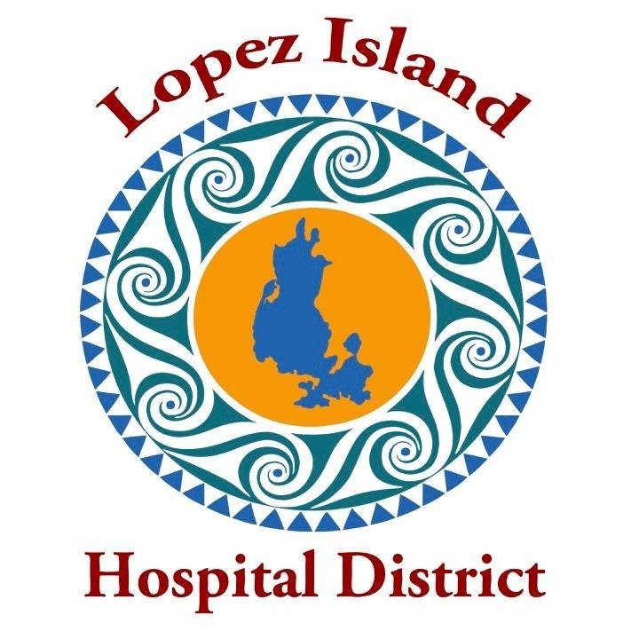
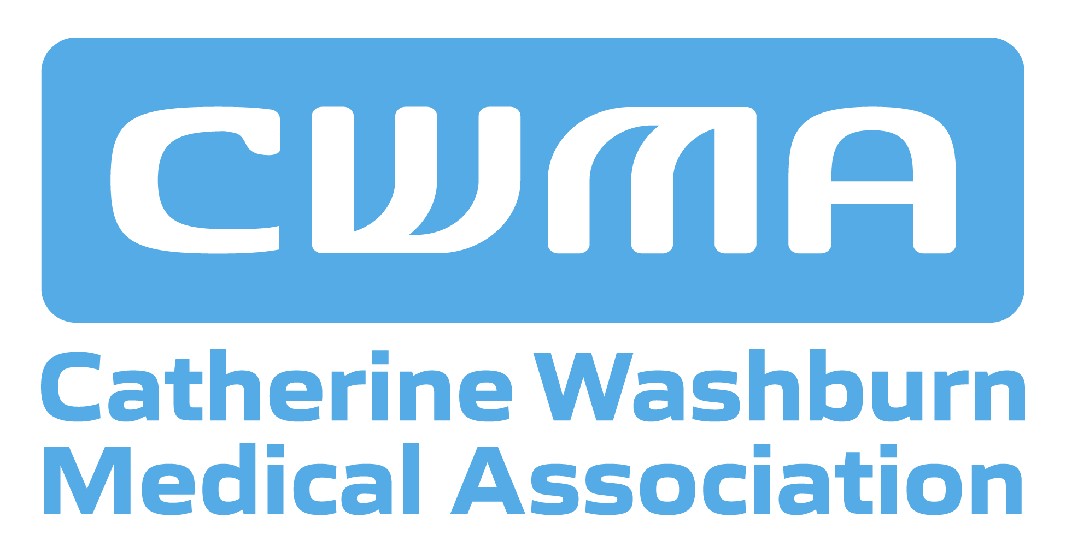

FAQs on Sea Mar Community Health Centers and the Lopez Clinic

When would the clinic be open under Sea Mar?
We expect Sea Mar to operate the clinic Monday – Friday, 8 am – 5 pm, at a minimum.

Will Sea Mar accept my insurance?
Sea Mar accepts many major types of insurance, including Medicare, Medicaid, Ambetter, United HealthCare, WellPoint, Molina, and CHPW.

Will I be able to call the Lopez Clinic directly, or will I be routed to a Sea Mar call center?
Patients will call the Lopez Clinic directly to schedule appointments and for other needs.

Will Sea Mar have a relationship with Lopez health care providers?
Sea Mar is actively discussing a strong working relationship and contracts with the Pharmacy and Physical Therapy, and has met with Lopez-based dentist Dr. Christine Aufderhar.

Why is Sea Mar interested in expanding to Lopez? Will we matter to Sea Mar when they have 90 other clinics around Washington State?
Serving the health care needs of a small, remote community is in keeping with Sea Mar’s mission of delivering high quality health care to underserved communities. Sea Mar is enthusiastic about the prospect of operating the Lopez Clinic, which would be aligned with their thriving Skagit County practice. Sea Mar has indicated that they are planning for the long-term and would like to attract more Lopezians to use the Lopez Clinic.

What will happen to the current Lopez Clinic staff? How will they recruit medical providers to our remote island?
Sea Mar has agreed to offer a position to all current clinic staff and match their current salary. Sea Mar has a proven record of recruiting medical providers in small communities and remote rural areas and offer programs to attract staff, such as paid training programs for medical assistant prospects.

What about a closer partnership with Lopez Fire/EMS?
Sea Mar has agreed to grant 24/7 access to the clinic for use by Lopez Fire/EMS.

Will Sea Mar provide a doctor for Lopez?
Sea Mar has agreed that at least one of the Lopez Clinic medical providers will be a doctor. After a final contract is signed, Sea Mar will work to recruit a doctor for the Lopez Clinic.

I’m seeing a UW specialist in Seattle. Will I be able to continue to do that under Sea Mar?
Sea Mar has agreed to honor patient preferences in referrals.

All my health records are in MyChart – how will I access them?
EPIC/MyChart is the records system used by Sea Mar health clinics, so we anticipate a smooth transition between UW and Sea Mar.

I’m not familiar with SeaMar. What do their patients think of the care they receive?
Patient experience surveys shared by Sea Mar from 2025 indicate high levels of patient satisfaction, especially interactions with providers.

What makes Sea Mar a good fit for Lopez?
Operating more than 90 community-based clinics, Sea Mar has a 48-year history of delivering quality primary health care to diverse communities in Washington State. Many Sea Mar clinics are located in small communities and rural areas.

Sea Mar was one of the first community health centers accredited by Joint Commission and has received the Gold Seal of Approval by demonstrating compliance with national standards for health care quality and safety. Reviews of their quality outcomes indicate high quality health care at a reasonable cost.

Sea Mar is a nonprofit corporation founded by Latino community activists and health advocates who sought to establish a Seattle health center, with satellite clinics in rural communities. In 1978, Sea Mar opened its first clinic in Seattle’s South Park neighborhood and in 1985, it opened a second clinic in Mount Vernon in the Skagit Valley. Today, Sea Mar operates eight Skagit clinics in Mount Vernon, Anacortes and Concrete, including Primary Care, Women’s Clinic and Maternity Services.

