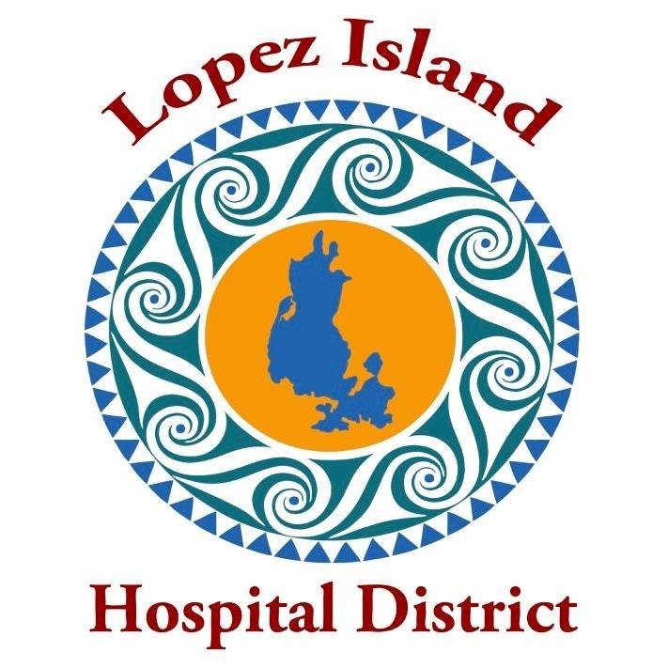
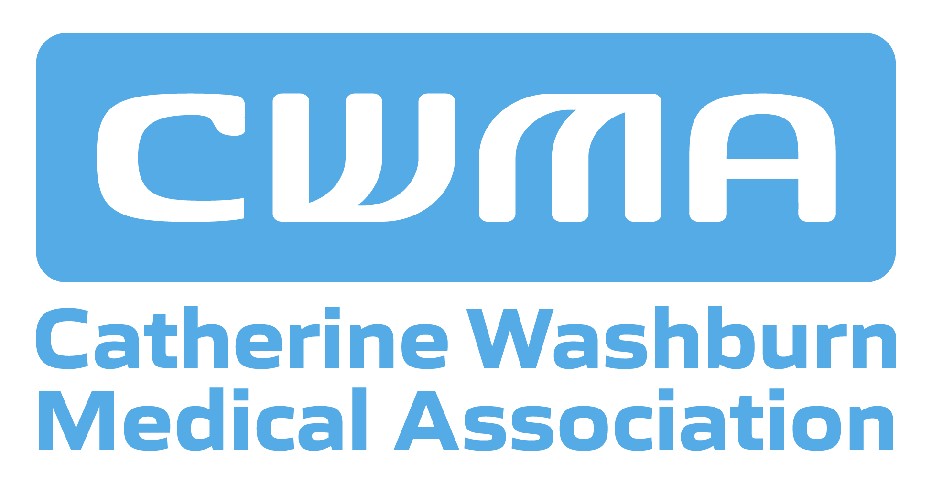

FACT SHEET: NEGOTIATIONS WITH SEA MAR COMMUNITY HEALTH CENTERS

Sea Mar Community Health Centers (Sea Mar) has been selected as the preferred option to operate the Lopez Island Medical Clinic, and negotiations are underway to reach an agreement.
When UW announced that it would end its operation of the Lopez Clinic in June 2026, the Lopez Island Hospital District (LIHD) and Catherine Washburn Medical Association (CWMA) immediately launched a joint committee to find a new clinic partner to ensure that the Lopez Island Medical Clinic would remain open without interruption. Outside experts were brought in to assist with the search and negotiations.

QUALITY HEALTH CARE INFORMED BY LOPEZ VIEWS AND VALUES
Operating more than 90 community-based clinics, Sea Mar has a 48-year history of delivering quality primary health care to diverse communities in Washington State, including many clinics in small communities and rural areas.

Since the UW announcement, the LIHD has gathered public input from more than 600 Lopez households through board meetings, community surveys, listening sessions and a town hall meeting, and this honest, heartfelt, and creative input helped shape our search for a new clinic operator and the negotiations with Sea Mar.

Sea Mar has initially agreed to provide the following, pending completion of the final agreement:
- Minimum staffing of 1.5 FTE medical providers, with at least one being a doctor
- Minimum clinic hours of 8 am – 5 pm, Monday through Friday
- Access to same day care at the clinic and telehealth access
- Access to pediatric, OB/GYN and behavioral specialists in Mt. Vernon and Anacortes
- Honor patient preference in referrals to specialists
- Offer to hire current clinic staff at current salaries
- EMS access to clinic to stabilize patients 24/7
- Health education for patients
- EPIC/My Chart medical records system
- Monthly quality and fiscal reviews with the Hospital District
Sea Mar has indicated that they would be ready to be fully operational on Lopez by July 1, 2026 when UW will cease operation of the clinic. Sea Mar is in discussions with Lopez-based health care organizations to explore potential partnerships.

FINANCIAL SUSTAINABILITY
Sea Mar has indicated that they may require a smaller subsidy from the Hospital District than the subsidy provided to UW. Sea Mar is a Federally Qualified Health Center, which would enable the Lopez Medical Clinic to receive additional federal resources. At the same time, Sea Mar never turns a patient away, regardless of ability to pay.

A reduced Hospital District subsidy suggests that no additional tax levy is anticipated and funds may be available for investments in services such as after-hours care.

Sea Mar has developed the systems legally required to operate health clinics, including centralized billing, records, human resources, and regulatory compliance.

BACKGROUND ON SEA MAR COMMUNITY HEALTH CENTERS
Sea Mar was one of the first community health centers accredited by Joint Commission and has received the Gold Seal of Approval by demonstrating compliance with national standards for health care quality and safety. Reviews of their quality outcomes indicate high quality health care at a reasonable cost.

Sea Mar is a nonprofit corporation founded by Latino community activists and health advocates who sought to establish a Seattle health center, with satellite clinics in rural communities. In 1978, Sea Mar opened a clinic in Seattle’s South Park neighborhood and in 1985, it opened a second clinic in Mount Vernon in the Skagit Valley.

Today in Skagit County, Sea Mar operates eight clinics in Mount Vernon, Anacortes and Concrete, including Primary Care, a Women’s Clinic and Maternity Services.

OTHER OPTIONS
While negotiations with Sea Mar are underway, exploration of the option of an independent clinic is still an option if negotiations are not fruitful. Of the eight health systems responding to our request for proposals, all but Sea Mar have either withdrawn from consideration to provide a long term solution or it has been determined they are unable to meet the community requirements to operate the clinic.

For more information and updates on the process, visit the LIHD website at
www.lopezislandhd.org/transition. For background on Sea Mar, visit the Sea Mar Community Health Centers website at www.seamar.org.

